# **Tutorial 01: Fundamentals of HTML**

## **Contents:**

Tutorial 01: Fundamentals of HTML 1

1.1. Contents: 1

1.2. What is HTML: 2

1.3. HTML basic Syntax: 2

1.4. HTML Tags: 3

1.5. HTML Versions: 3

1.6. HTML Editor: 4

1.6.1. HTML Editor – Step 1 - Open Notepad (PC): 4

1.6.2. HTML Editor – Step 2 - Write Some HTML: 4

1.6.3. HTML Editor – Step 3 - Save the HTML Page: 5

1.6.4. HTML Editors – Step 4 - View the HTML Page in Your Browser: 5

1.7. HTML Headings tag: 6

1.8. HTML Paragraphs tag: 6

1.9. HTML Links tag: 7

1.10. HTML Images tag: 7

1.11. HTML Attributes: 7

1.11.1. Title Attribute: 7

1.12. HTML Table: 8

1.13. Unordered HTML List: 8

1.14. Ordered HTML List: 9

1.15. HTML Forms: 9

1.15.1. Form Action Attribute: 10

1.15.2. Form Method Attribute: 11

1.16. The <select> Element: 11

1.17. The <textarea> Element: 11

References: 13

## **What is HTML:**

* HTML is the standard markup language for creating Web pages.
* HTML stands for Hyper Text Markup Language
* HTML describes the structure of Web pages using markup
* HTML elements are the building blocks of HTML pages
* HTML elements are represented by tags
* HTML tags label pieces of content such as "heading", "paragraph", "table", and so on
* Browsers do not display the HTML tags, but use them to render the content of the page.

## **HTML basic Syntax:**

<!DOCTYPE html>

<html>

<head>

<title>**Page Title**</title>

</head>

<body>

<h1>**My First Heading**</h1>

<p>**My first paragraph.**</p>

</body>

</html>

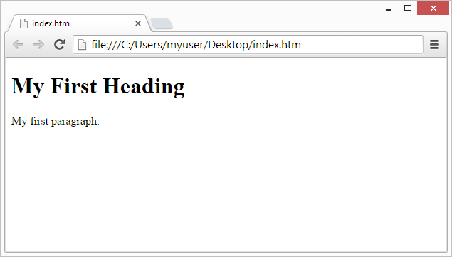

Figure 1: The web browser (Chrome, IE, Firefox, Safari) is to read HTML documents and display them. The browser does not display the HTML tags, but uses them to determine how to display the document.

1. The <!DOCTYPE html> declaration defines this document to be HTML5.
2. The <html> element is the root element of an HTML page
3. The <head> element contains meta information about the document.
4. The <title> element specifies a title for the document
5. The <body> element contains the visible page content
6. The <h1> element defines a large heading
7. The <p> element defines a paragraph

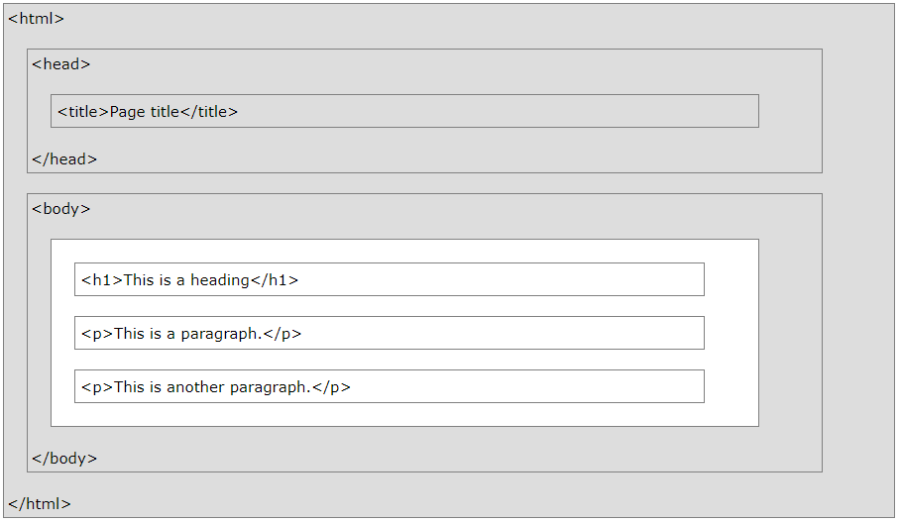

Figure 2: HTML Page Structure.

## **HTML Tags:**

* HTML tags are element names surrounded by angle brackets:

<tagname> **content goes here...** </tagname>

* HTML tags normally come **in pairs** like <p> and </p>
* The first tag in a pair is the **start tag (opening tag),** the second tag is the **end tag (closing tag).**
* The end tag is written like the start tag, but with a **forward slash** inserted before the tag name.

## **HTML Versions:**

Since the early days of the web, there have been many versions of HTML:

|  |  |
| --- | --- |
| **Version** | **Year** |
| HTML | 1991 |
| HTML 2.0 | 1995 |
| HTML 3.2 | 1997 |
| HTML 4.01 | 1999 |
| XHTML | 2000 |
| HTML5 | 2014 |

## **HTML Editor:**

* Web pages can be created and modified by using professional HTML editors.
* However, for learning HTML we recommend a simple text editor like Notepad (PC) or TextEdit (Mac).
* We believe using a simple text editor is a good way to learn HTML.
* Follow the four steps below to create your first web page with Notepad or TextEdit.

### **HTML Editor – Step 1 - Open Notepad (PC):**

* **Windows 8 or later:**
  + Open the **Start Screen** (the window symbol at the bottom left on your screen). Type **Notepad**.
* **Windows 7 or earlier:**
  + Open **Start** >**Programs >** **Accessories >** **Notepad**

### **HTML Editor – Step 2 - Write Some HTML:**

Write or copy some HTML into Notepad.

<!DOCTYPE html>

<html>

<body>

<h1>**My First Heading**</h1>

<p>**My first paragraph.**</p>

</body>

</html>

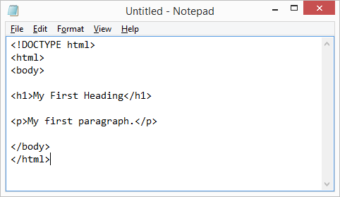

Figure 3: HTML code in Notepad.

### **HTML Editor – Step 3 - Save the HTML Page:**

* Save the file on your computer. Select **File > Save as** in the Notepad menu.
* Name the file **"index.htm"** and set the encoding to **UTF-8** (which is the preferred encoding for HTML files).

**Note:** You can use either .htm or .html as file extension. There is no difference, it is up to you.

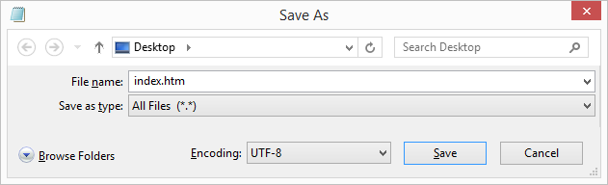

Figure 4: Save the HTML page.

### **HTML Editors – Step 4 - View the HTML Page in Your Browser:**

Open the saved HTML file in your favorite browser (double click on the file, or right-click - and choose "Open with"). The result will look much like this:



Figure 5: Your page in the Browser.

## **HTML Headings tag:**

* HTML headings are defined with the **<h1>** to **<h6>** tags.
* <h1> defines the most important heading. <h6> defines the least important heading:

<!DOCTYPE html>

<html>

<body>

<h1>**This is heading 1**</h1>

<h2>**This is heading 2**</h2>

<h3>**This is heading 3**</h3>

<h4>**This is heading 4**</h4>

<h5>**This is heading 5**</h5>

<h6>**This is heading 6**</h6>

</body>

</html>

## **HTML Paragraphs tag:**

* HTML paragraphs are defined with the **<p>** tag:

<!DOCTYPE html>

<html>

<body>

<p>**This is a paragraph.** </p>

<p>**This is another paragraph.** </p>

</body>

</html>

## **HTML Links tag:**

* HTML links are defined with the **<a>** tag.
* The link's destination is specified in the **href attribute**.
* Attributes are used to provide additional information about HTML elements.

<!DOCTYPE html>

<html>

<body>

<a href=**"https://www.w3schools.com"**> **This is a link** </a>

</body>

</html>

## **HTML Images tag:**

* HTML images are defined with the **<img>** tag.
* The source file (src), alternative text (alt), width, and height are provided as attributes

<!DOCTYPE html>

<html>

<body>

<img src=**"w3schools.jpg"** alt=**"W3Schools.com"** width=**"104"** height=**"142"**>

</body>

</html>

## **HTML Attributes:**

* All HTML elements can have **attributes**
* Attributes provide **additional information** about an element
* Attributes are always specified in **the start tag**
* Attributes usually come in name/value pairs like: **name="value"**

### **Title Attribute:**

A **title** attribute is added to the **HTML** element. The value of the title attribute will be displayed as a tooltip when you mouse over the HTML element.

<!DOCTYPE html>

<html>

<body>

<h2>**The title attribute**</h2>

<p title=**"I'm a tooltip"**> **Mouse over this paragraph, to display the title attribute as a tooltip.**</p>

</body>

</html>

## **HTML Table:**

* An HTML table is defined with the **<table>** tag.
* Each table row is defined with the **<tr>** tag.
* A table header is defined with the **<th>** tag. By default, table headings are bold and centered.
* A table data/cell is defined with the **<td>** tag.

**Note:** The <td> elements are the data containers of the table. They can contain all sorts of HTML elements; text, images, lists, other tables, etc.

<!DOCTYPE html>

<html>

<body>

<table border=**"1"**>

<tr><th>**Firstname**</th>

<th>**Lastname**</th>

<th>**Age**</th>

</tr>

<tr><td>**Jill**</td>

<td>**Smith**</td>

<td>**50**</td>

</tr>

</table>

</body>

</html>

## **Unordered HTML List:**

* An unordered list starts with the **<ul>** tag. Each list item starts with the **<li>** tag.
* The list items will be marked with bullets (small black circles) by default.

<!DOCTYPE html>

<html>

<body>

<h2>**Unordered List**</h2>

<ul>

<li>**Coffee**</li>

<li>**Tea**</li>

<li>**Milk**</li>

</ul>

</body>

</html>

## **Ordered HTML List:**

* An ordered list starts with the **<ol>** tag. Each list item starts with the **<li>** tag.
* The list items will be marked with numbers by default.

<!DOCTYPE html>

<html>

<body>

<h2>**Ordered List**</h2>

<ol>

<li>**Coffee**</li>

<li>**Tea**</li>

<li>**Milk**</li>

</ol>

</body>

</html>

## **HTML Forms:**

* The HTML **<form>** element defines a form that is used to collect user input.
* An HTML form contains **form elements**.
* Form elements are different types of input elements, like text fields, checkboxes, radio buttons, submit buttons, and more.
* The **<input>** element is the most important form element.
* The <input> element can be displayed in several ways, depending on the **type** attribute.

<!DOCTYPE html>

<html>

<body>

<form>

**First name:**<br>

<input type=**"text"** name=**"firstname"**><br>

**Last name:**<br>

<input type=**"text"** name=**"lastname"**>

</form>

</body>

</html>

Note: **<input type="text">** defines a one-line input field for **text input.**

<!DOCTYPE html>

<html>

<body>

<form>

<input type=**"radio"** name=**"gender"** value=**"male"** checked> **Male** <br>

<input type=**"radio"** name=**"gender"** value=**"female"**> **Female** <br>

<input type=**"radio"** name=**"gender"** value=**"other"**> **Other**

</form>

</body>

</html>

Note: **<input type="radio">** defines a **radio button**. Radio buttons let a user select ONE of a limited number of choices.

<!DOCTYPE html>

<html>

<body>

<form action=**"/action_page.php"**>

**First name:**<br>

<input type=**"text"** name=**"firstname"** value=**"Mickey"**><br>

**Last name:**<br>

<input type=**"text"** name=**"lastname"** value=**"Mouse"**> <br><br><input type=**"submit"** value=**"Submit"**>

</form>

</body>

</html>

Note: **<input type="submit">** defines a button for **submitting** the form data to a **form-handler**. The form-handler is typically a server page with a script for processing input data.

### **Form Action Attribute:**

* The **action** attribute defines the action to be performed when the form is submitted.
* Normally, the form data is sent to a web page on the server when the user clicks on the submit button.
* In the example above, the form data is sent to a page on the server called "/action_page.php". This page contains a server-side script that handles the form data.

<form action=**"/action_page.php"**>

### **Form Method Attribute:**

* The **method** attribute specifies the HTTP method (**GET**or **POST**) to be used when submitting the form data.

<form action=**"/action_page.php"** method=**"get"**>

**OR**

<form action=**"/action_page.php"** method=**"post"**>

## **The <select> Element:**

* The **<select>** element defines a **drop-down list**
* The **<option>** elements defines an option that can be selected.
* By default, the first item in the drop-down list is selected.
* To define a pre-selected option, add the **selected** attribute to the option.

<!DOCTYPE html>

<html>

<body>

<form action=**"/action_page.php"**><select name=**"cars"**>

<option value=**"volvo"**>**Volvo**</option>

<option value=**"saab"**>**Saab**</option>

<option value=**"fiat"**>**Fiat**</option>

<option value=**"audi"**>**Audi**</option>

</select><br><br>

<input type=**"submit"**>

</form>

</body>

</html>

## **The <textarea> Element:**

* The **<textarea>** element defines a multi-line input field (**a text area**).
* The **rows** attribute specifies the visible number of lines in a text area.
* The **cols** attribute specifies the visible width of a text area.

<!DOCTYPE html>

<html>

<body>

<form action=**"/action_page.php"**>

<textarea name=**"message"** rows=**"10"** cols=**"30"**>**The cat was playing in the garden.**</textarea>

<br><br>

<input type=**"submit"**>

</form>

</body>

</html>

# **References:**

* <https://www.w3schools.com/html>